Highly Oxidized Graphene Nanosheets via the Oxidization of Detonation Carbon
A. Nepal¹, G. Chiu¹, J. Xie², G. P. Singh³, N. Ploscariu¹ S. Klankowski⁴, T. Sung¹, J. Li⁴, B. N. Flanders¹, K. L. Hohn², and C. M. Sorensen^{1*}
¹ Department of Physics, Kansas State University, Manhattan, KS 66506, USA
² Department of Chemical Engineering, Kansas State University, Manhattan, KS 66506, USA
³ Centre for Nanotechnology, Central University of Jharkhand, Ranchi-835205, Jharkhand, India
⁴ Department of Chemistry, Kansas State University, Manhattan, KS 66506, USA
* Corresponding Author (Email:sor@phys.ksu.edu)
Supporting information
Atomic Force Microscopy (AFM) of graphene nanosheets (GNs) and oxidized graphene nanosheets OGNs:
Sample preparation:
Samples of GNs and OGNs for AFM studies were prepared from their dispersions in ethanol at concentration 0.01 mg/ml for each. GNs and OGNs in ethanol at this concentration were dispersed and exfoliated by sonicating for 2 hours in an ultrasonic water bath (Branson 2510). The dispersions were then centrifuged for 15 minutes at 1000 rpm to let the heavier and un-exfoliated flakes settle. The supernatant was transferred into a petri dish. A silicon substrate was immersed into the supernatant and incubated for 2 minutes at room temperature. The substrates were then rinsed by immersing briefly into DI water. After rinsing, these substrates with expected thin layers of GNs and OGNs were dried using nitrogen flow and used for AFM imaging.
Characterization:
AFM topographical images of the GNs and OGNs samples were acquired in air, at room temperature, using contact mode AFM (Bruker USA, Innova). The AFM scanner was calibrated using a TGZ1 silicon grating (NT-MDT, USA). MLCT-E cantilevers (Bruker, USA) with nominal spring constants of 0.1 N/m were used with set point contact forces of 1 nN or less. The topographical images were flattened by subtracting the background and then re-plotted using a second order equation incorporated in the Gwyddion analysis software [1].
Measurements and discussions:
The size and thickness of the GNs and OGNs flakes were assessed from the AFM profile lines. The thinnest flake of GNs analyzed and measured was a bi-layer structure shown in figure S1(a). The first step in the profile line of GNs, figure S1(b), has a height of ~ 0.9 nm while the second step has a height of ~ 0.36 nm. This height of first step is approximately the same as the thicknesses (~1nm) of the single layers of substrate-supported graphene that were reported earlier [2,3]. An atom thick layer of graphene may exhibit a step height of ~1 nm when observed via AFM due to the following possible reasons: (i) attached molecules on the graphene surfaces; (ii) imperfect interface between the contacting surfaces; (iii) and different magnitudes of attractive forces between AFM probes and the silicon substrate [2,4]. The bi-layer GNs profiled in figure S1(a) has a double layer profile with the bottom layer protruding laterally. The surface of the top layer sits 0.36 nm above the bottom layer. This interlayer spacing agrees with the interplanar spacing of 0.341 nm that was measured in GNs samples via XRD. Furthermore, the lateral size of GNs measured from profile line (Fig. S1b) is about 250 nm; this value is consistent with the lateral sizes that we measured with TEM.
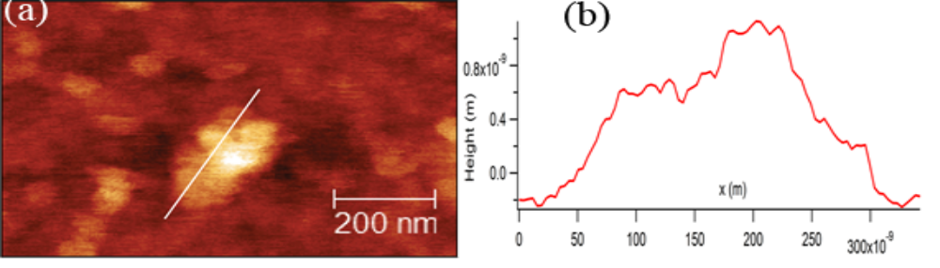
Figure S1: (a) AFM image of a 0.9 x 0.6 μm GNs flake (b) Profile line across the flake in panel (a). The measured approximate lateral length of the flake was 250 nm. Measured initial step was 0.9 nm high and the second step was at a height of 0. 36 nm from the first.
AFM image of OGNs flakes is shown in figure S2(a) . The OGNs flakes have lateral size of about 240 nm measured along the profile 1 in figure S2(a) as seen in the plot, figure S2 (b). This size of OGNs is very close to the size predicted by TEM image of the same.
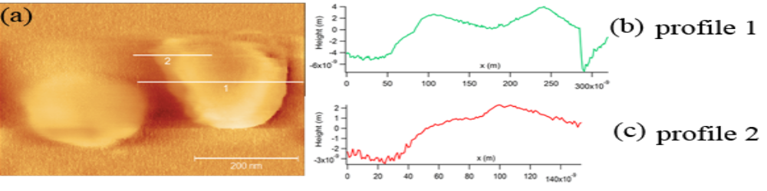
Figure S2 : (a) AFM image of 0.6x0.4 μm OGNs flake (b) Profile line across the flake along line 1 in panel (a), and (c) Profile line across the edge of the flake along line 2 in panel (a). The approximated lateral length of the flake was around 240 nm, an initial step height was ~ 3.7 nm, the measured height difference between the initial step (short plateau) and second plateau was ~ 0.8 nm.
The initial step height of 3.7 nm in the profile line of OGNs (Fig S2 b and c) is more than 1 nm, that for single layer GNs. This might be because of OGNs edge folded downward on the substrate. It might also be an un-exfoliated, multilayered clump of OGNs.
The profile line in figure S2(b) shows humps and plateaus. Highly oxidized (C/O ~1/1) OGNs layers are not expected to remain flat and smooth. Rather, they are likely to exhibit significant folding because extent of folding increases with the degree of oxidation [5]. The humps on the profile line represent these intrinsic ripples and folds along OGNs surface. However, a careful look at profile 2 in figure S2(a) (and plotted in figure S2c) shows very short plateaus. The spacing between neighboring plateaus is ~0.8 nm. This value is close to the interplanar spacing of ~ 0.879 nm obtained from the XRD of OGNs.
In conclusion, the layer morphology, size and interplanar spacing of GNs and OGNs were studied with AFM, and the observed features are in reasonable agreement with the lateral sizes and interplanar spacing that have been observed independently via TEM and XRD.

References:
1. D. Necas, P. Klapetek, Cent. Eur. J. Phys. 10, 181(2012)
2. S. Wang, Y. Zhang, N. Abidi , L. Cabrales, Langmuir 25(18),11078 (2009)
3. J. I. Paredes, S. Villar-Rodil, A. Martınez-Alonso, J. M. D. Tascon, Langmuir 24,10560 (2008)
4. X. L. Li, X. R. Wang, L. Zhang, S. W. Lee, H. J. Dai, Science 319, 1229 (2008)
5. T. Szabo , O. Berkesi, P. Forgo, K. Josepovits, Y. Sanakis, D. Petridis, I. Dekany, Chem. Mater., Vol. 18, No. 11, 2741(2006)

